**Project presentation**

Good morning Ladies and gentleman,

I am lekshmi s r of s6 mca. may I welcome you all to attend my project presentation on “BSN-CARE”. My internal guide is prof. Anjana J.

**INTRODUCTION**

I propose a modern healthcare system making use of latest technologies like IOT and BSN called IOT based BSN-CARE. The system consists of bio-sensors and a microcontroller unit worn by the patient and the output forward to family member or friend using IOT and mobile network. The system envisages provision of quality and affordable medical care on real time at their door step.

**OBJECTIVE AND SCOPE**

* IOT based modern healthcare is primarily intented to take care of the health aspects of older people staying alone. The system envisages to real time monitoring of the health parameters of dependent patients and provide timely and quality healthcare to them.
* Objective of the project is to make affordable, fully secure and timely healthcare to the dependent patients. The system make use of Body sensor network which with the help of iot and internet measures and forward the health parameters of patients on real time.
* The patients data base is passed on to designated family member/friend on real time by Blynk/cloud server through mobile network who then take appropriate action to save the patient.

**EXISTING SYSTEM**

Existing medical care is manual as a patient has to physically go to a doctor/hospital for treatment. In most of the cases a patient has to wait in queue for long time to get consultation/medicine. This becomes very difficult for senior citizen and emergency cases as travel and waiting is involved before getting treatment. The present system is expensive and time and effort consuming.

**DRAWBACKS OF EXISTING SYSTEM**

* Existing System is inefficient.
* It is very tedious and time consuming.
* Lack of safety and security.
* Complexity.
* More human efforts.
* Implementation Issues.
* High Expenses.

**PROPOSED SYSTEM**

* **IOT BASED BSN-CARE**

The proposed system is meant to provide quality and affordable healthcare to all patients on real time by taking advantage of most modern technologies like bio-sensors, IOT & mobile network. The system when fully developed and integrated will be available world-wide.

The system proposed consist of a wrist band, Temperature sensor, Heart rate pulse sensor worn by patient. NodeMCU and Temperature sensor DHT 11, Pulse sensor are embedded on to the wrist band itself. Temperature, pulse rate & oxygen level are measured by sensors clipped on to a finger tip and wired to NodeMCU. C++ embedded code will be uploaded using android applications. The medical data base of the patient is then transmitted through the mobile network to the designated family member or friend on real time and thus the patient getting timely medical care.

With the rapid advancement of technology with profound influence of IOT and sensor technology. BSN-CARE will make quantum jump in days to come and will be widely used globally. The proposed system is undoubtedly a boon to all patients particularly isolated veterans & slum dwellers.

I have used the following components in my project:

* Wrist band
* Node mcu
* Temperature sensor
* Heart beat pulse sensor amped

**ADVANTAGES OF PROPOSED BSN-CARE**

* It is cost effective.
* Health parameters are passed on through healthcare provider on real-time.
* It uses solar power.
* The system can be implemented easily.
* It is safe and secure.
* Easy to maintain.
* User friendly and lightweight.
* Chronic disorders are identified at the primary stage itself by the doctors for better decision making.
* Future expansion is possible.
* BSN healthcare is the ideal way of treatment for all during spread of pandemic like corona virus.

**HARDWARE REQUIREMENTS**

**NODE MCU ESP8266 1.0 WIFI MODULE**

Node mcu is a nano chip on the wrist band to which other sensors are also connected sensors feed their output to the nano chip which convert them to digital signal and is fed to the cloud server application. ESP 8266 node mcu is used in the project.

NodeMCU is an open source development board and firmware based in the widely used [ESP8266 -12E WiFi module](http://store.fut-electronics.com/products/wifi-esp8266-12-serial-ttl-module-esp-12). It allows you to program  the ESP8266 WiFi module with the simple and [powerful LUA programming language](http://http/www.lua.org/about.html) or Arduino IDE.

With just a few lines of code you can establish a WiFi connection and define input/output pins according to your needs exactly like Arduino, turning your ESP8266 into a web server and a lot more. It is the WiFi equivalent of ethernet module. Now you have internet of things (iot) real tool.

With its USB-TTL, the nodeMCU Dev board supports directly flashing from USB port. It combines features of WIFI access point and station + microcontroller. These features   make the NodeMCU extremely powerful tool for Wifi networking. It can be used as access point and/or station, host a webserver or connect to internet to fetch or upload data.

**Features**

* Finally, programable WiFi module.
* Arduino-like (software defined) hardware IO.
* Can be programmed with the simple and powerful Lua programming language or Arduino IDE.
* USB-TTL included, plug & play.
* 10 GPIOs D0-D10, PWM functionality, IIC and SPI communication, 1-Wire and ADC A0 etc. all in one board.
* Wifi networking (can be used as access point and/or station, host a web server), connect to internet to fetch or upload data.
* Event-driven API for network applications.
* PCB antenna.

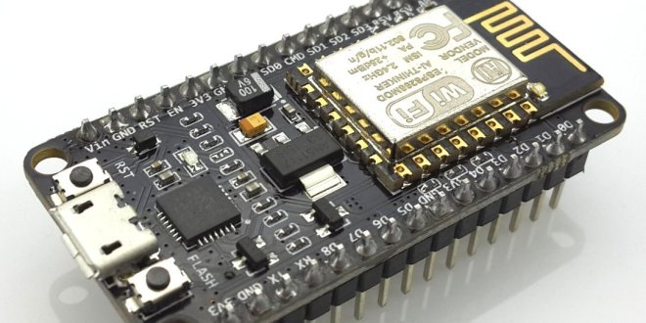

**DHT11 TEMPERATURE SENSOR**

The **DHT11**is a commonly used **Temperature and humidity sensor.** The sensor comes with a dedicated NTC to measure temperature and an 8-bit microcontroller to output the values of temperature and humidity as serial data. The sensor is also factory calibrated and hence easy to interface with other microcontrollers. DHT11 is a low-cost digital sensor for sensing temperature and humidity.  This sensor can be easily interfaced with any micro-controller such as Arduino, Raspberry Pi etc… to measure humidity and temperature instantaneously. DHT11 humidity and temperature sensor is available as a sensor and as a module. The difference between this sensor and module is the pull-up resistor and a power-on LED. DHT11 is a relative humidity sensor.  To measure the surrounding air this sensor uses a [thermistor](https://www.elprocus.com/introduction-to-thermistor-types-with-its-workings-and-applications/) and a capacitive humidity sensor.

**WORKING PRINCIPLE**

DHT11 sensor consists of a capacitive humidity sensing element and a thermistor for sensing temperature.

For measuring temperature this sensor uses a Negative Temperature coefficient thermistor, which causes a decrease in its resistance value with increase in temperature. To get larger resistance value even for the smallest change in temperature, this sensor is usually made up of semiconductor ceramics or polymers.

The temperature range of DHT11 is from 0 to 50 degree Celsius with a 2-degree accuracy. it gives one reading for every second.  DHT11 is small in size with operating voltage from 3 to 5 volts. The maximum current used while measuring is 2.5mA.

DHT11 sensor has four pins- VCC, GND, Data Pin and a not connected pin. A pull-up resistor of 5k to 10k ohms is provided for communication between sensor and micro-controller.

**APPLICATIONS**

This sensor is used in various applications such as measuring humidity and temperature values in heating, ventilation and air conditioning systems. Weather stations also use these sensors to predict weather conditions.  The humidity[sensor](https://en.wikipedia.org/wiki/Humidity) is used as a preventive measure in homes where people are affected by humidity.  Offices, cars, museums, greenhouses and industries use this sensor for measuring humidity values and as a safety measure.

**DHT11 Specifications:**

* Operating Voltage: 3.5V to 5.5V
* Operating current: 0.3mA (measuring) 60uA (standby)
* Output: Serial data
* Temperature Range: 0°C to 50°C
* Humidity Range: 20% to 90%
* Resolution: Temperature and Humidity both are 16-bit
* Accuracy: ±1°C and ±1%

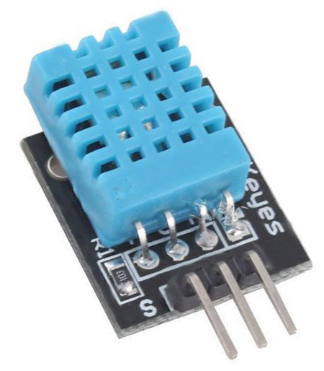

HEART RATE PULSE SENSOR AMPED

Heart rate pulse sensor amped is a such type of sensor which is mainly used for sensing heartbeat rate. Normally it is very difficult task to measure the exact heartbeat rate, but this have become so much easy with the help of this pulse sensor amped. If we talk about heartbeat, then heart beat is a periodic signal that is produced by any software or hardware system for giving intimation to normal of working of any system. For measuring this periodic intimation signal, so many sensors have been using currently in market but here we shell only talk about pulse sensor amped. This is basically plug and play heartbeat sensor and have been using by makers, athletes, game developers and students in their hardware projects. It is easily available in market or online shop.

**Working Principle of Heart Rate Pulse Sensor**

The working principle of this heartbeat rate sensor is very simple. If we talk about heartbeat rate, then heartbeat rate is the ratio of time between two consecutive heartbeats. Similarly, when the human blood is circulated in human body then this blood is squeezed in capillary tissues. As a result, the volume of capillary tissues is increased but this volume is decreased after each heartbeat. This change in volume of capillary tissues, effects on the LED light of heart rate pulse sensor, which transmits light after each heartbeat.

This change in light is very small but this can be measured by connecting any controller with this pulse sensor. Means, the LED light which have every pulse sensor helps for measuring pulse rate. The working of this sensor could be checked by placing human finger in front of this pulse sensor. When finger is placed in front of this pulse sensor then the reflection of LED light is changed based on the volume of blood change inside capillary vessels. Means during heartbeat the volume of blood in capillary vessels will be high and then will be low after each heartbeat. So, by changing this volume the LED light is changed. This change in of LED light measures the heartbeat rate of finger.

**APPLICATIONS**

* Wireless supervision of people during hazardous operations.
* In an overcrowded emergency department.
* Chronic surveillance of abnormal heart failure.
* In cardio-vascular disease for monitoring the hyper tension.

**ADVANTAGES**

* Continuous monitoring.
* Easy to use.
* Reducing hospitalization fee.
* It directly calibrated the temperature in Celsius (centigrade).
* It basically detects the present expression of patient.
* In this the heart beat sensor gives the digital output to the microcontroller & output from microcontroller gives the rate in beats per minute (BPM).

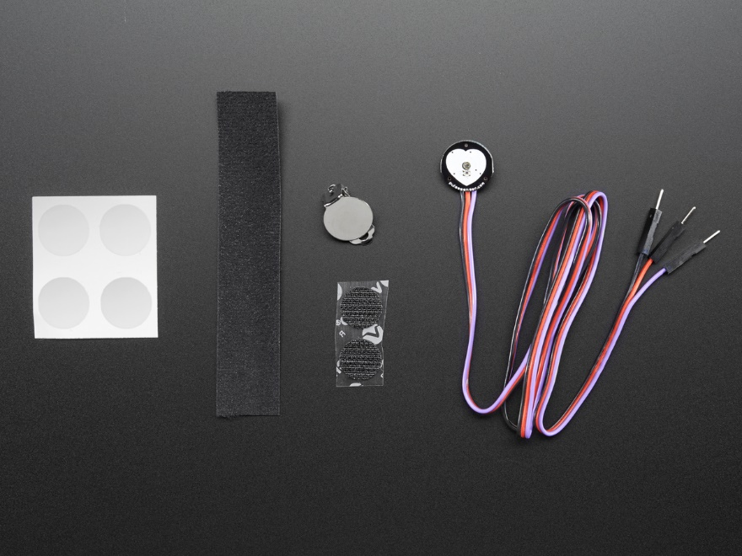

**Measuring pulse rate**

During each heart beat the blood gets squeezed into capillaries which results in expansion of volume slightly and in between heart beats, the volume of capillaries decreases. This change in volume affects the amount of red or infrared light that passes through the tissues. This small fluctuation can be measured by a pulse oximeter to give us the pulse rate.

**Measuring blood oxygen saturation**

Blood oxygen saturation can be measured by comparing the values of hemoglobin (Hb) and HbO2(A variant of Hb) in the blood. This is done by shinning a Red LED and an infra-Red LED, through a finger or wrist of an ‘individual’ and comparing their relative intensity. Blood oxygen level saturation is determined from this using various methods.

**DESCRIPTION**

* BLOCK DIAGRAM Sensors output of the sensors worn by the patient namely Temperature sensor, Heart beat pulse sensor, oxygen level and pulse rate sensor are fed to the NODE MCU.
* These sensor data is uploaded to Thingspeak using NODE MCU. Blynk server then forward the coded data to family member or friend and to healthcare server when integrated.
* The data so received is analysed and interpreted by the healthcare server when fully developed who takes timely action. In this case the family member or friend who is connected to sensor output should be capable of taking necessary action on receipt of sensor data or alert notification on the mobile network or Email.
* In case of up normal readings of pulse rate, temperature and oxygen level a led light on patients wrist band will glow and simultaneously an alarm will be sounded. This is a caution to the patient and family members who stays with him who can take appropriate action.
* Friend of the patient also get a Blynk notification on mobile and a message on Email. The same information will also be available on Thingspeak of the mobile of friend or caregiver.
* The medical data base of the patient will be stored for a year by the Thingspeak which can be seen when required.

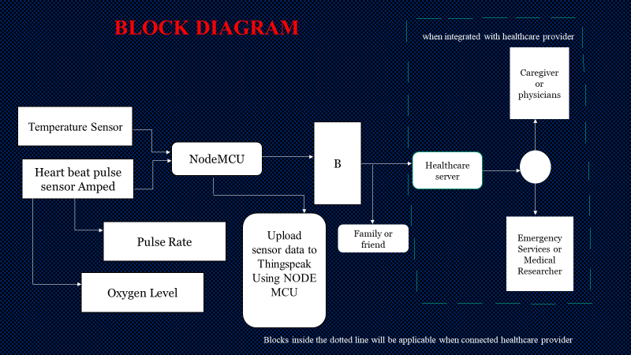

**THINGSPEAK**

Thingspeak is an IoT analytics platform service that allows you to aggregate, visualize and analyse live data streams in the cloud. Thingspeak provides instant visualizations of data posted by your devices to Thingspeak. With the ability to execute MATLAB code in Thingspeak you can perform online analysis and processing of the data as it comes in. Thingspeak is often used for prototyping and proof of concept IoT systems that require analytics.

**Thingspeak key Features**:

* Easily configure devices to send data to Thingspeak using popular IoT protocols.
* Visualize your sensor data in real-time.
* Aggregate data on-demand from third-party sources.
* Use the power of MATLAB to make sense of your IoT data.
* Run your IoT analytics automatically based on schedules or events.
* Prototype and build IoT systems without setting up servers or developing web software.
* Automatically act on your data and communicate using third-party services like Twilio or Twitter.

**BLYNK APPLICATION**

* **Open Source Android App (Blynk)-:** Blynk is an open source android app which is designed and developed in order to control the hardware via internet of things (IOT). This digitally displays sensor data, it can accumulate and visualize the data. Plus, it can also do other parameters such as:
* **Blynk App**: This app gives us to create amazing interfaces for a project using multiple widgets which is an in-build app.
* **Blynk server**: It acts as an interface between the smartphone and hardware which is responsible for the communication. We can also use blynk cloud or compile our private blynk server. It’s an open source that can control any number of devices plus can also be launched on Raspberry pi.
* **Blynk Libraries**: For all the standard hardware platforms, supports communication with the sensor and the complete progression of incoming and outgoing instructions.

**CONCLUSION**

* IOT based BSN-CARE healthcare system is undoubtedly going to revolutionize the existing conventional healthcare practices of the world.
* Formation of long queues in hospitals and in front of renowned doctors for specialist consultation etc. will soon be a thing of the past.
* Modern IOT based BSN healthcare system envisages provision of quality and timely healthcare at your door step based on data received on real time at the exclusive healthcare network.
* More over global consultation of expert renowned specialist doctors will be just a click away when fully developed worldwide.
* Further BSN healthcare will be a boon to slum dwellers as quality and affordable treatment can be provided to them on real time at their door step.
* BSN healthcare is the ideal way of treatment for all during spread of pandemic like corona virus.

**FUTURE ENHANCEMENT**

* The system can be enhanced to cover in remote villages where IOT can be gainfully utilised.
* Body sensors in due course of time will be employing most modern technologies to minimise or make the radiations negligible.
* Since internet and mobile network has conquered the whole world making the whole world a global village IOT based BSN healthcare can be extended to benefit the whole global population.
* IOT based BSN healthcare will revolutise the field of medical care in due course of time benefitting the whole world.
* Once fully developed and fully integrated consultation of an expert specialist anywhere in the world will be just a click away from you.

Thanking you all for spending your valuable time to listen to my brief project presentation.

I am grateful to the honourable guest for sparing their valuable time and taking pains to attend my presentation. I like to extend my sincere thanks for all of you for your kind gesture.